



**American Philanthropic Association:**

*Microfinancing Crowdfunding Application*

**Student Packet**

**Federal Recruiting Case Competition**

**2016**

**TABLE OF CONTENTS**

1. Introduction 4

2. Schedule & Logistics 5

3. Rules & Guidelines 6

Preparing your Solution 6

Solution and Materials Collection 6

Presentation Day 6

4. Case Competition Fact Pack 7

Problem Description 7

About the Client 7

Student Tasks 7

American Philanthropic Association 9

APA at a Glance 9

Client Overview 10

APA and Mobile Technology: Current State 10

APA and Mobile Technology: Future State 11

Technical Platform Design 12

Implementation Risks 15

Risks of Mobile Application Development 15

Risks of Mobile Website Development 16

Security Measures to Mitigate and Prevent Risks 17

Additional Considerations 18

Implementation Strategy 18

Key Performance Indicators 19

Training 22

5. Judging Criteria & Presentation Requirements 24

Understanding of the Problem 24

Recommendation 24

Presentation 24

Question & Answer Session 24

**FIGURES**

[Figure 1: Email from APA Director Swanson 11](https://projects.deloittefed.com/sites/FedCampusRecruiting/strategy/All%20DocumentsMaterials/Case%20Competitions/Case%20Comp%202016%20-%20APA/Planning/APA%20Case%20Competition%20-%20Packet%20Skeleton%202016%20(002).docx#_Toc443569096)

[Figure 2: Email from APA CTO Cannon 14](https://projects.deloittefed.com/sites/FedCampusRecruiting/strategy/All%20DocumentsMaterials/Case%20Competitions/Case%20Comp%202016%20-%20APA/Planning/APA%20Case%20Competition%20-%20Packet%20Skeleton%202016%20(002).docx#_Toc443569097)

[Figure 3: App Development Process 15](https://projects.deloittefed.com/sites/FedCampusRecruiting/strategy/All%20DocumentsMaterials/Case%20Competitions/Case%20Comp%202016%20-%20APA/Planning/APA%20Case%20Competition%20-%20Packet%20Skeleton%202016%20(002).docx#_Toc443569098)

[Figure 4: Mobile Application Security Issues 16](https://projects.deloittefed.com/sites/FedCampusRecruiting/strategy/All%20DocumentsMaterials/Case%20Competitions/Case%20Comp%202016%20-%20APA/Planning/APA%20Case%20Competition%20-%20Packet%20Skeleton%202016%20(002).docx#_Toc443569099)

[Figure 5: Back-End Application Development 16](https://projects.deloittefed.com/sites/FedCampusRecruiting/strategy/All%20DocumentsMaterials/Case%20Competitions/Case%20Comp%202016%20-%20APA/Planning/APA%20Case%20Competition%20-%20Packet%20Skeleton%202016%20(002).docx#_Toc443569100)

[Figure 6: Front-End Application Development 17](https://projects.deloittefed.com/sites/FedCampusRecruiting/strategy/All%20DocumentsMaterials/Case%20Competitions/Case%20Comp%202016%20-%20APA/Planning/APA%20Case%20Competition%20-%20Packet%20Skeleton%202016%20(002).docx#_Toc443569101)

Figure 7: Email from APA CTO Cannon 21

[Figure 9: Email from APA CTO Cannon 22](https://projects.deloittefed.com/sites/FedCampusRecruiting/strategy/All%20DocumentsMaterials/Case%20Competitions/Case%20Comp%202016%20-%20APA/Planning/APA%20Case%20Competition%20-%20Packet%20Skeleton%202016%20(002).docx#_Toc443569103)

[Figure 8: Effective KPI Development 22](https://projects.deloittefed.com/sites/FedCampusRecruiting/strategy/All%20DocumentsMaterials/Case%20Competitions/Case%20Comp%202016%20-%20APA/Planning/APA%20Case%20Competition%20-%20Packet%20Skeleton%202016%20(002).docx#_Toc443569104)

[Figure 10: Email from APA VP Hodges 23](https://projects.deloittefed.com/sites/FedCampusRecruiting/strategy/All%20DocumentsMaterials/Case%20Competitions/Case%20Comp%202016%20-%20APA/Planning/APA%20Case%20Competition%20-%20Packet%20Skeleton%202016%20(002).docx#_Toc443569105)

**ARTICLES**

Article 1: Introduction to APA 10

Article 2: APA's Budget and Timleine 10

[Article 3: Mobile Technology in Developing Nations 13](https://projects.deloittefed.com/sites/FedCampusRecruiting/strategy/All%20DocumentsMaterials/Case%20Competitions/Case%20Comp%202016%20-%20APA/Planning/APA%20Case%20Competition%20-%20Packet%20Skeleton%202016%20(002).docx#_Toc443569039)

[Article 4: Mobile Website v Mobile App 15](https://projects.deloittefed.com/sites/FedCampusRecruiting/strategy/All%20DocumentsMaterials/Case%20Competitions/Case%20Comp%202016%20-%20APA/Planning/APA%20Case%20Competition%20-%20Packet%20Skeleton%202016%20(002).docx#_Toc443569040)

Article 5: Entrepreneurship Throughout the World 20

Article 6: Vetting Crowdfunding Ecosystems 20

Article 7: Strategic KPI Definition 21

Article 8: Training Users 24

# 1. Introduction

Case studies are designed to give you a glimpse into a day in the life of a technology consultant solving real-life business problems. This particular case focuses on a potential problem at a fictional Federal agency. The solution you generate will address the client problem and requirements -- and present a technologically feasible recommendation. Many of the skill sets you demonstrate and ideas you generate will be representative of what entry-level practitioners do at their respective client sites every day. Within this packet you will find:

* Details on the case scenario
* Background information on the client
* Supporting articles and figures to provide you with further details
* An explanation of the problem and questions you are required to address
* Judging criteria
* Rules and logistical information

Please note, you are not limited to the materials in this packet, but the provided content should be *more than adequate* for teams to formulate a solution.

This is a great opportunity to further build upon your team work, presentation, critical thinking and analytical skills. It is also a chance to network with Deloitte practitioners and learn more about our career opportunities and internship programs.

Thank you for your interest and participation. Good Luck!

**DISCLAIMER:** The entirety of this coursepack, as well as any documents related to this case and/or belonging to Deloitte, is not to be re-distributed.

# 2. Schedule & Logistics

|  |  |  |  |
| --- | --- | --- | --- |
| Date | Time | Description | Location  (if applicable) |
| Friday, March 18th | Afternoon | Student Material Distribution | N/A |
| Tuesday, March 29th | No later than 11:59 PM | E-mail Solution Presentation (PowerPoint) | The Deloitte Vanderbilt University Recruiting Mailbox |
| Wednesday, March 30th | 8:40AM – 3PM | Solution Presentations & Winner Announcements/Networking | Sarratt 216/220 |

# 3. Rules & Guidelines

## Preparing your Solution

* **Internet usage:** As noted above, internet usage is allowed but not necessary to develop your team’s solution. Please do not cite “wiki” sources as part of your solution.
* **Solution development:** Tailor your solution to the judging criteria found within your participant packet.
* **Help on solution development and competition questions:** Reach out to your designated coach (you’ll receive a separate e-mail connecting you with your coach) for any questions you may have. Refer to all case materials distributed.
* **Information gathering restrictions:** You may not call any industry or company analysts or other experts.
* **Deck template:** Use the template provided to you within the Deloitte Case Competition kickoff email.

## Solution and Materials Collection

* **Turning in your solution:** Presentations should be sent to the Deloitte Vanderbilt University Recruiting Mailbox by 11:59 PM on Tuesday, March 29th. Please title the subject of the email ***2016 Vanderbilt University Deloitte Technology* Team Name:** Please use the naming convention “TeamName_CaseSolution.ppt” for your solution file.

## Presentation Day

* **Solution presentation:** Team presentations must be **10-15** minutes long. This does not include time allotted for Q&A. The Q&A portion of the presentation will be **5** minutes long.
* **Presentation order:** The order of presentation will be assigned. Please email the Deloitte Vanderbilt University Recruiting mailbox at [vandyrecruiting@deloitte.com](mailto:vandyrecruiting@deloitte.com) with your 3 preferred time slots. We will do our best to accommodate schedules. **Please also note that all teams must be present for the entire 15-20 minute time block.**
* **Presentation check-in:** We ask all team members to be present around 15 minutes prior to the start of your presentations to check in with the Deloitte representatives.
* **Presentation logistics:** We will have laptops available with presentations preloaded for the day of presentations. However, we do recommend bringing a flashdrive or other form of backup of your presentation (could be hard copies as well). We will provide clickers for teams to use to navigate the presentations.
* **Technical difficulties:** Your team is responsible for any technical difficulties encountered during the presentation. While these things can be unforeseen, your team should have a contingency plan in place in the event that this happens. Extra time will not be allotted for time spent dealing with any technical issues experienced.
* **Talk time:** Each team member needs to present during the presentation. Equal talk time is advised. Stay within your allotted time slot.
* **Q&A session:** Questions will be asked of the group during the last **5** minutes of the designated time slot. Questions may be directed toward the group as a whole or individually.

# 

# 4. Case Competition Fact Pack

## Problem Description

The American Philanthropic Association (APA) aims to further its mission of ending poverty and promoting democratic societies through strategizing and enacting international development initiatives. In order to meet this goal, while combatting a continuously shrinking year-over-year budget, APA plans to fund these initiatives with the aid of the American public through the creation of a crowdfunding application. This application would connect entrepreneurs in developing countries to the much-needed funding they require to further develop their ventures and, in turn, enhance the economic climate of their communities. Other community members will profit off the success of an entrepreneur’s venture through employment and access to the much needed goods or services that the venture provides. Overall, this proposed crowdfunding application has the potential to strengthen international economies by helping to lower the number of citizens living in poverty. To incentivize American citizens to back international projects, APA has been approved for section 170(c) tax deductions amounting to 15% of the amount donated.

Additionally, APA hopes to analyze data collected through this application to further justify the impact of international development initiatives. APA aims to gather metrics with the goal of researching the impact of crowdfunding and microfinance initiatives, justifying investment technological innovations for philanthropic means, and countering budget cuts in the future.

## About the Client

APA is the only Federal government agency that aims to further the success of developing countries through the elimination of poverty. Founded in the 1970s during the Vietnam War, APA hopes to develop international economies to solidify the foundation of successful, peaceful democratic societies while simultaneously enhancing the perception and security of American citizens.

## Student Tasks

Students should operate as though they are Deloitte consultants. All recommendations should be structured as though you are a member of the firm.

**Students should recommend a design and deployment plan for a system that takes into account APA requirements, technical feasibility, and any relevant tradeoffs or alternatives.**

In constructing their recommendations, students should consider the following:

* + Technological Design:
    - What kind of application will you develop (e.g. mobile, web, etc.)?
    - What information will you collect in the application (e.g. funding, potential projects, ongoing projects, etc.)?
    - How do you define the success of this application (e.g. key performance indicators – KPIs)?
  + Security analysis:
    - What risks can you foresee with this application?
    - What can you do to avoid or mitigate for these risks?
  + Implementation options:
    - How will you deploy the recommended application?
    - Consider the various risks and benefits of different deployment options (big bang, pilot, phased approaches).
    - What training methodology best suits the timeline and financial constraints?

**Additionally, keep the following points in mind to assist your response to the client.**

* Consider how to handle the hurdles associated with the target citizens’ current technological environment, as well as, the cultural, institutional and economic factors that may suppress entrepreneurship.
* Consider how to connect entrepreneurs to the right audience for crowdfunding and how to validate that the project is credible.
* Assess the pros and cons of different implementation strategies when developing a solution.
* Consider analyzing the pros and cons of alternative solutions.

## American Philanthropic Association

### APA at a Glance

Today, three quarters of the world’s impoverished citizens do not have a bank account and access to capital still remains a significant barrier throughout the developing world. To overcome these challenges and advance rapid, sustainable, broad-based growth, APA is focused on the following areas for FY16:

* **Accessibility to Markets –** Giving people access to markets where they can sell their goods and services and play a productive role in their economies;
* **Channels of Financing –** Encouraging local channels of financing, empowering entrepreneurs in developing countries to improve their lives and shape their own futures;
* **Mobile Technology –** Expanding the underprivileged‘s access to financial services through mobile phone technology. Mobile money services help those living in poverty reduce the cost of banking transactions and have been shown to increase savings.  Along with developing these services, APA is working to support a robust regulatory environment to ensure users’ money is not put at risk.

|  |
| --- |
| *Adapted from:* [*https://www.usaid.gov/what-we-do/economic-growth-and-trade*](https://www.usaid.gov/what-we-do/economic-growth-and-trade)  **Introduction to APA**  Through APA’s assistance programs, they invest in developing countries that will have long-term benefits for America and the American people. APA is a leading government agency that works to end extreme global poverty and enable resilient democratic societies to realize their potential and Deloitte is serving as the primary client on the crowdfunding project. Ensuring economic growth is broad-based and reducing poverty has become a fundamental development challenge. Developing entrepreneurs cannot obtain credit to start businesses or to grow their businesses or farms; impoverished citizens that own small businesses or ventures often have little help in getting access to new technologies or business networks that could improve opportunities to sell their products. APA programs enhance impoverished citizens’ access to financial services such as savings accounts and credit. |
| Article 1: Introduction to APA  APA is hoping to complete this project in the next year to accommodate for development, multiple iterations of testing, and deployment. Though this is an accelerated timeline, APA is confident in Deloitte to execute this project with minimal risk and provide the public with an intuitive application that will further APA’s strategic mission. |
| *Adapted from:* [*https://www.usaid.gov/results-and-data/budget-spending*](https://www.usaid.gov/results-and-data/budget-spending)  **APA’s Budget**  APA’s budget for the next fiscal year is predicted to be $3 million and is dedicated to advancing economic prosperity through initiatives that reduce poverty, improve education and workforce development, and strengthen resilience in the region. APA will provide expertise to governments of developing countries as they make necessary reforms, scale up proven community-based interventions, and train youth for a 21st century workforce, while helping businesses acquire the financial and market access they need to generate economic growth and jobs. This funding is part of the $10 million request for an inclusive whole-of-government approach to support the U.S. Strategy for Engagement |

Article 2: APA's Budget and Timeline

## Client Overview

### APA and Mobile Technology: Current State

The American Philanthropic Association recognizes the prevalence of mobile applications and general mobile device usage in today’s technology-dependent world. This rapid growth of use is evident in a multitude of industries, and companies are dependent on utilizing this platform for optimizing customer outreach. Companies often maintain a competitive and technological advantage if they keep up with rapid trends in such a technology driven society. Customers’ preferences are more focused on ease of use and convenience, which most can claim they find with the use of their mobile phone. Unfortunately, developing nations are slow to this trend due to the high price associated with many of these devices, such as industry’s latest smart phones and tablets. This is why mobile saturation has yet to occur and these nations are still implementing even the most basic instances of mobile technology. However, these simple technological functions, such as voice and SMS connections, have spurred rapid growth in education, health, and financial services within these rural areas. This technology has also been a savior in emergency crisis situations, where this speedier method helped the victims in need. This represents the urgent need to continue to implement the latest in technological developments within these developing countries, as they will continue to experience flourishing growth within their communities.

**From**: Swanson, Pat

**To**: APA Listserv; Alvarez, Kurt (US – Deloitte)  
**Subject**: Introducing APA’s New Partner

**Sent**: Saturday, October 17, 2015 2:03 PM

APA Employees,

Greetings! I hope this message finds you well. As you know, APA has had a tough couple of years recently, but we are optimistic on our path forward. We have exciting new product launches coming up in key markets, innovative customer interaction solutions in the wings, and many other initiatives underway that can help us gain stature in the industry.

We are excited to announce that we have partnered with Deloitte to bring in the newest technological advances and knowledge to deliver a mobile solution. This will allow those across the globe who truly need our services to be able to do so with the click of a button. Thanks to Kurt and the rest of the Deloitte team for joining us in this venture!

We look forward to paving the future in our industry. As always, feel free to email me or anyone else on our leadership team if you have comments, questions, concerns or suggestions.

Warm Regards,

Pat

**Pat Swanson**

**Director**

APA

Phone: (617) 867-9999 | Fax: (310) 211-9999

Figure : Email from APA Director Swanson

With an increasing number of studies being conducted on the prevalence of mobile technology throughout the developing world, mobile technology is continuously becoming more appealing to APA in an effort to support its mission of ending poverty and establishing peaceful, democratic societies worldwide. With a drive to bring innovation to the philanthropic initiatives that APA establishes, while being sustainably-conscious of all current and future initiatives to combat a shrinking budget, APA acknowledges the benefits that mobile technology can provide.

Social media tools at APA have grown over the past few years and the agency is doing its best to get the word out to citizens. APA now maintains a blog with information on connecting with the agency through various forms of social media. This blog contains links that describe how to connect to their twitter and mobile twitter accounts, as well as twitter links for specific regions. They also attempted to update the site with appropriate hashtags for specific financial events in order to help collect data about socioeconomic demographics and frequency. This effort proved to be successful; however, hashtags tend be created in a more organic nature at the time of a given event. Facebook, YouTube, Google+, and LinkedIn are among other social media platforms the agency is attempting to use. Few details are currently available about how APA plans to use each of these platforms and how the combined data the platforms produce can be used to support the organization’s mission.

### APA and Mobile Technology: Future State

Recently, APA has been focusing its efforts on targeting the youth market due to the opportunity to spark an interest in crowdfunding from an earlier age. With the growth of millennials relying on their phones to perform various financial transactions, a mobile application would cater to their needs and provide an easier method of involvement in supporting these various international communities. This will allow them to reach a more extensive target market and advance their international development initiatives. Additionally, APA aims to continue their mission in being sustainably conscious, as well as meticulous with their financial investments due to their shrinking budget. APA continues its plans to expand their ventures internationally and continue to expand their technological platforms, in order to constantly keep up with the latest in technology trends.

This drive to become mobile is evident in APA’s most recent investment. In December, APA recently implemented APATrack – an internal mobile application that APA officers can use in the field to track the history and progress of community development initiatives that have been established. Information tracked and shared includes the type of development initiative (e.g., infrastructure support, economic development, supply distribution), the number of individuals assisted, amount of APA funding allocated to the initiative, and which APA officers were overseeing the initiative’s success. This mobile application has greatly helped increase the collaboration between similar, but often disparate, APA initiatives and tracked the success of development initiatives to justify additional funding in future years. From the success of APATrack, APA is looking to further support current and future initiatives through the use of mobile technology.

## Technical Platform Design

As APA is considering various applications, it has grown clear how important application accessibility and usability is to enable project clients in developing countries, donors, and APA system operators to be able to connect and understand the application. APA is considering three different application types: website, mobile website, and mobile application. While each platform has its own individual benefits, APA wants to use the method that best aligns with its strategic goals, including accessibility and usability.

Article : Mobile Technology in Developing Nations

|  |
| --- |
| *Adapted from:* [*http://www.pewglobal.org/2014/02/13/emerging-nations-embrace-internet-mobile-technology/*](http://www.pewglobal.org/2014/02/13/emerging-nations-embrace-internet-mobile-technology/)  **Mobile Technology in Developing Nations**  Technology 3Technology 09In recent years, the usage of cell phones has almost become ubiquitous in many developing and emerging countries. This new utilization of mobile technology has impacted the developing world in several ways, with individuals using this new capability to send and receive messages, pictures, and even payments.  A survey was conducted collecting information on mobile technology and internet usage from over 24,000 individuals from 24 developing countries. The results, stated below, depict that although mobile technology is very much dispersed throughout emerging countries, there is still a larger number of individuals that are offline. However, this number is shrinking due to the increasing prevalence of smartphones. With cell phones and smartphones becoming more available to citizens of developing countries, it is common for these citizens to bypass acquiring a landline phone and directly purchase a cell phone.    Although messaging is the most common usage for cell phones in emerging countries, Africa has seen great success in sending and receiving payments via cell phones. The figure to the right depicts the percentage of cell phone owners, not smartphones, who send or receive payments on their phone. |

|  |
| --- |
| *Adopted from <http://www.hswsolutions.com/services/mobile-web-development/mobile-website-vs-apps/>*  Figure : Email from APA CTO Cannon  **From**: Cannon, Irene  **To**: Flowers, Adam (US – Deloitte) **Subject**: APA Mobile App  **Sent**: Monday, October 19, 2015 6:42 AM  Adam,  I was thinking about what types of designs most suit the needs of APA at the time and I believe that the options are between a mobile app and a mobile website (though I’m leaning towards the app!). Can you all at Deloitte do analysis between the pros and cons of each?  I need to get my organization behind me. Also, it looks like the budget is going to be less than expected, somewhere in the neighborhood of $1.5M. Let’s shoot to present solutions in this range.  Best,  Irene  **Irene Cannon**  **Chief Technology Officer**  APA  Phone: (617) 747-9399 | Fax: (310) 231-9879  **Mobile Website vs Mobile App**  **What’s the Difference Between a Mobile Website and an App (Application)?**  Before you can evaluate the benefits of a mobile website vs. an app it’s important to understand the key differences between the two. Both apps and mobile websites are accessed on a handheld devices such as smartphones (e.g. iPhone, Android and Blackberry) and tablets. For example, CNN has the option of using their app or navigating to cnn.com, both can be accessed using a mobile phone, but have different means of getting there.  A [mobile website](http://hswsolutions.com/services/mobile-web-development/advantages) is similar to any other website in that it consists of browser-based HTML pages that are linked together and accessed over the Internet (for mobile typically WiFi or 3G or 4G networks). The obvious characteristic that distinguishes a mobile website from a standard website is the fact that it is designed for the smaller handheld display and touch-screen interface.  Like any website, mobile websites can display text content, data, images and video. They can also access mobile-specific features such as click-to-call (to dial a phone number) or location-based mapping.  Apps are programs that are downloaded and installed on your mobile device, rather than being rendered within a browser. Users visit device-specific portals such as Apple’s App Store, Android Market, or Blackberry App World in order to find and download apps for a given operating system. The app may pull content and data from the Internet, in similar fashion to a website, or it may download the content so that it can be accessed without an Internet connection.  **Which is Better – an App or a Mobile Website?**  When it comes to deciding whether to build a native app or a mobile website, the most appropriate choice really depends on your end goals. If you are developing an interactive game an app is probably going to be your best option, but if your goal is to offer mobile-friendly content to the widest possible audience then a mobile website is probably the way to go. In some cases you may decide you need both a mobile website and a mobile app, but it’s pretty safe to say that it rarely makes sense to build an app without already having a mobile website in place.  Generally speaking, a mobile website should be considered your first step in developing a mobile web presence, whereas an app is useful for developing an application for a very specific purpose that cannot be effectively accomplished via a web browser.  As long as mobile remains a relatively new frontier, the “app vs web” question will remain a very real consideration for organizations seeking to establish a mobile presence. If your mobile goals are primarily marketing-driven, or if your aim is to deliver content and establish a broad mobile presence that can be easily shared between users and found on search engines, then the a mobile website is the logical choice. On the other hand, if your goal is interactive engagement with users, or to provide an application that needs to work more like a computer program than a website, then an app is probably going to be required. |

Figure : App Development Process

Article : Mobile Website v Mobile App

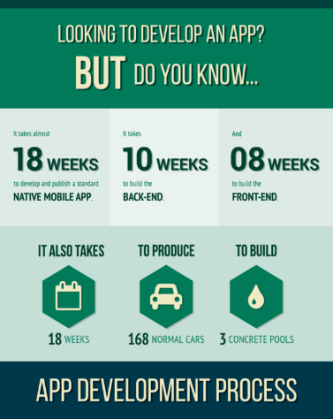

**Key considerations for application lifecycle development.**

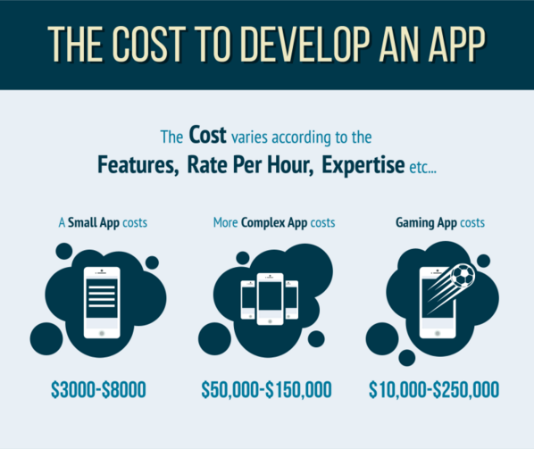

## Implementation Risks

### Risks of Mobile Application Development

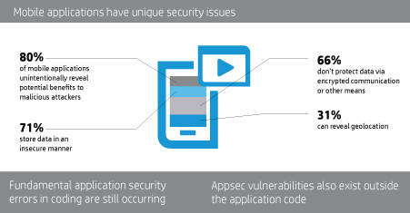Mobile application development has high potential for success, but is not without its fair share of risks and security concerns. According to a Veracode study that examined hundreds of thousands of mobile apps in corporate environments, researchers found 14,000 applications to be unsafe. Within those unsafe applications, 85% exposed sensitive device data, including: phone location, credit card information, phone contacts, and SMS message logs. An additional study revealed that 78% of top Android and iPhone applications have been hacked. This represents the rapid rise of mobile application safety concerns, and the importance of having a secure application environment. The diagram on the right reveals some fascinating statistics about the prevalence of application security issues.

Figure : Mobile Application Security Issues

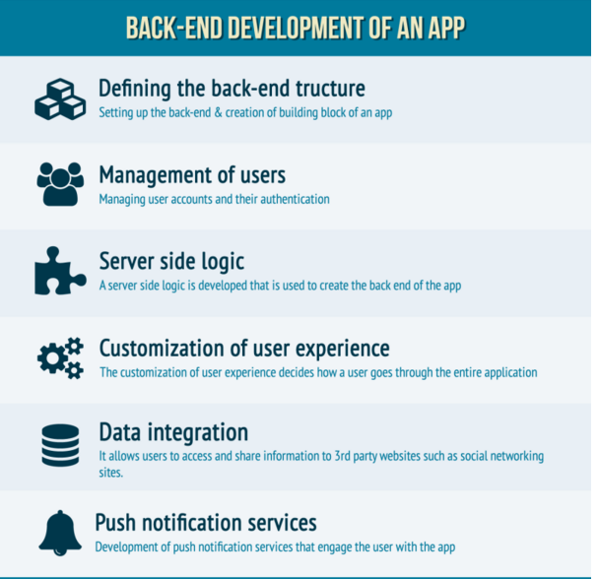Other recent studies reveal that the most significant security issues found were exposure of sensitive data, performance of suspicious security actions, and collection of personal information. This is a significant issue for applications in which financial transactions occur and credit card information must be securely protected on the application. For example, popular applications such as Uber and Venmo, which center around transactional use, maintain state of the art security measures to prevent theft and access to confidential data. Another common risk within the development process is the occurrence of vulnerabilities, which are errors in design or implementation that expose the data to various methods of interception. For example, this could lead to: data leakage, insecure data storage, and unsafe data transmission. An additional developmental flaw is weak server-side controls, if unauthorized personnel have access to the code and overall data. Finally, spyware issues allow for extensive security threats, which lead to a higher likelihood of a data breach in which hackers gain access to confidential data. This issue is extremely prominent, as a recent report revealed an estimated 16 million mobile devices worldwide have been infected by malware. All of these risks have significant implications if they are not properly prevented, such as: intellectual property theft, revenue loss, fraud, altered user experience and brand damage.

Figure : Back-End Application Development

Additionally, the grandiose investment of both time and money can be a heavy burden on many companies. The average development time for a mobile application is around 18 weeks to incorporate both front-end and back-end design. The initial development costs of a complex application ranges from $50,000 to $150,000, not including maintenance efforts such as security updates, and ongoing design and development costs. Before a company decides to make such a significant investment, they must assess whether this risk has a significant potential for reward. These diagrams represents the cost and length factors to consider when deciding to develop a mobile application. They also are a visual representation of the different elements that go into front end and back end design.

### Risks of Mobile Website Development

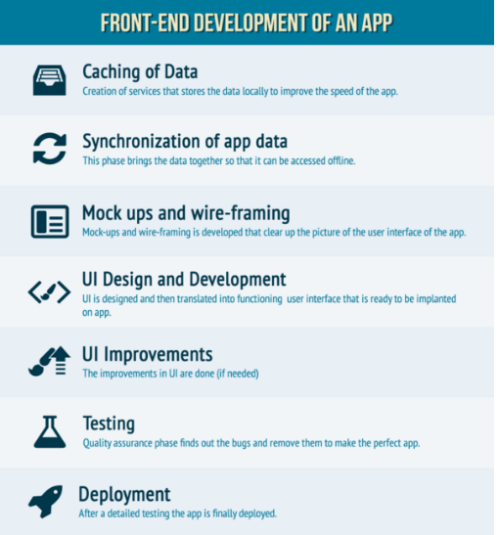There are also many security risks and considerations when developing a mobile website, as opposed to solely an application. A recent study revealed that malicious URL contributed up to 86% to mobile attacks in 2012. This reveals the prominence of ensuring the URL code is valid and trustworthy, before clicking on it and exposing a mobile device to severe risk. Another prominent issue is phishing, in which many mobile users claim that they have a difficult time recognizing a phishing attempt. This can lead to significant data breaches, and providing confidential information to unauthorized sources. Especially pertaining to websites which handle financial transactions, the ability to protect the user’s payment information is critical especially when instilling trust for the customer. For example, the rise and prominence of mobile banking websites represents the depth of security measures that goes into protecting the vast amount of customers. The prominence of phishing is an issue all throughout the world, but especially in the United States. Therefore, wherever the website is developed, it must always be protected from phishing efforts.

Figure : Front-End Application Development

Generally speaking, mobile browsers are at a higher risk of vulnerabilities than desktop browsers due to the higher percentage of risky interactions. Potential data hackers can come from SMS, social messengers, e-mail, various applications, etc. This statistic below, from a LinkedIn research study, represents the significance in developing a secure, user-friendly website.

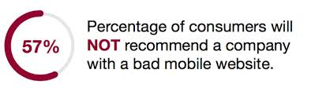Many of the security risks for mobile websites overlap with those of mobile applications, such as the exposure to various forms of spyware and viruses. It is critical to implement the best anti-virus software that the company can afford, in order to not compromise the time and effort gone into the initial development of the mobile website. Additionally, the collection of personal information and exposure of sensitive data are also prominent security risks with not only mobile applications, but websites as well. The most common vulnerabilities that mobile websites are exposed to, are the same as the ones for the mobile applications. For example: weak server-side controls, and insecure data storage pose a significant risk to the mobile industry as a whole. These vulnerabilities can lead to more critical issues, such as: unwanted data transmission, data leakage, etc. All of these outcomes could potentially be damaging to the relationship with the customer, taking away the trust with providing this confidential information. In order to prevent weak server-side controls, it is imperative that all efforts are put forth to ensure that only authorized personnel have access to the code used during development. Another risk with solely developing a mobile website as opposed to an application, is the inconvenience for the customer which may result in less frequency of use. In today’s technology-driven society, customers are looking for the most user-friendly way to access a company’s information. Many research studies have revealed that customers find useability of an application to be much more convenient. This is a tough dilemma for many companies since the cost of development is far more extensive for an application, but the potential for success may be more significant.

### Security Measures to Mitigate and Prevent Risks

In order to avoid these risks, proper security efforts need to be implemented early in the application development process. First, developers should follow coding best practices in the design process, and continually assess to identify potentially exploitable flaws. Also, extra protection of encrypted data, passwords, and geo-location data is necessary to ensure confidentiality for the user. Developers should also adjust the security measures based on the corresponding platform whether it is operating system, type of phone, etc. Additionally, the implementation of industry’s best anti-virus software is a necessity to protect from malware, spyware, viruses, etc. Further security measures of prevention would be to require passwords for users every time they launch an application so that hackers do not gain access to it. An alternative to this would be to program the cache to be automatically erased each time the mobile device reboots, and this would further help prevent data vulnerabilities. Companies should also frequently revisit the application in order to perform regular security updates, so that the application’s safety is not compromised over time.

It is also critical to implement sufficient testing protocol before launching the application, to ensure the application is successful and secure for its users. Developers should test the application on hundreds of devices to ensure it works on a high percentage of the customer base. A recent study revealed that a minimum of 399 different user devices is a necessity to ensure the application is functional on unique mobile devices. Another highly recommended procedure is for a company to invest in creating its own mobile testing lab, to allow for the most efficient and personal testing solution for your application. It is also critical to test on various network operators, such as LTE, CDE, and GSM to ensure the application does not rely on one sole network, and works dynamically. This also refers to the testing the application with various networks internationally, in which the entrepreneurs have in their developing nations.

Additionally, testing solutions should be adapted base on whether it is a native, mobile, or hybrid application. Finally, automated or manual scripting is a necessity for testing in which a test engineer tracks the success and failure rate of the script running. If all this testing protocol is implemented, the chances of security risks with the application are significantly lower, leading to a higher overall success rate. Companies must also test every possible inlet for security issues, whether it be GPS, cameras, sensors, etc.

## Additional Considerations

### Implementation Strategy

In the early days of the crowdfunding industry, the primary focus was building strong credit options. However, this sector has become very dynamic and organizations face new market challenges that include fierce competitors, selective customers, and a demand for diversified products. Microfinance organizations have begun to recognize that their operations would be strengthened by using private sector marketing techniques. Defining APA’s brand is a highly valuable asset and an effective implementation strategy will help APA gain a credible reputation.

|  |
| --- |
| *Adapted from:* [*http://blog.approvedindex.co.uk/2015/06/map-entrepreneurship-around-the-world/*](http://blog.approvedindex.co.uk/2015/06/map-entrepreneurship-around-the-world/)  **Entrepreneurship Throughout the World**  Due to the availability of resources within advanced countries, there are many inherent advantages for entrepreneurs residing in the countries. There are, however, many other deterrents hindering the establishment and development of entrepreneurial ventures within these countries. Resulting from the ubiquity of successful ventures that have evolved into large corporations, and the state of industrialization within developed countries, entrepreneurs face higher barriers to entries. The largest and most difficult hurdle to cross is that of positioning the venture within the market. With a market that becomes increasingly more permeated by successful ventures, differentiating a new venture becomes much more difficult.  Developing countries face much lower barriers to entry. Although many developing countries find entrepreneurial resources scarcer, as a result of this the market is void of many of the large overbearing corporations that reaped the benefits of industrialization. All in all, when unemployment is high and the economy is weaker, people are forced to start small businesses.  Entrepreneurship is defined as the percentage of an adult population who own a new business. Recent research was conducted into the entrepreneurial landscape of countries and which countries are the overall “most entrepreneurial”. This information is depicted in the maps, as a percentage of entrepreneurs by the adult population. |

Article 5: Entrepreneurship throughout the World

|  |
| --- |
| **Vetting Crowdfunding Ecosystems**  When determining which communities can foster a successful crowdfunding platform, it is crucial to consider several key factors that enable the success of both the venture and platform. These elements of success include the ecosystem’s entrepreneurial culture, technological infrastructure, community engagement, and economic regulations.  **Entrepreneurial Culture –** the success of ventures is dependent on a country’s cultural and legal environment in addition to any economic incentives for both entrepreneurs and funders. All of these influences affect the level of risk and barriers to entry that entrepreneurs face when creating a venture. Countries that have been successful in incentivizing entrepreneurs to take on this risk, have enacted policies to institutionalize this culture into communities, including incubators, accelerators, and mentorships.  **Technological Infrastructure –** emerging technology and business methodologies can further advance entrepreneurs in developing countries. Increasing their access to capital through mobile applications, social media, and crowdfunding initiatives can increase their chances of success, but this successes is dependent on the adoption of the technology as well as a country’s infrastructure to host such technology.  **Community Engagement –** engaging communities, both those of potential entrepreneurs and funders, is essential to drive the success of crowdfunding platforms. Community engagement plays a crucial role in bridging the gap between funders and entrepreneurs as well as creating a culture of “failure acceptance.” If the proper infrastructure is in place, technology serves as a successful medium for community engagement via social media and mentorship opportunities.  **Economic Regulation** – the economic policies of a country strongly dictate the success of entrepreneurial ventures. Governments that enact regulations that make it difficult to create, or further sustain, business initiatives will prove ineffective for fostering economic development benefits from crowdfunding efforts.  When making efforts to foster economic development via crowdfunding initiatives, it is crucial to consider the following factors when establishing a strategy for international crowdfunding. |

Article 6: Vetting Crowdfunding Ecosystems

### Key Performance Indicators

In recent years APA has made an effort to promote the use of new technologies to help aid in funding international development initiatives. With the growth in the use of mobile technologies by our citizens APA has realized it must create tools which are compatible with mobile platforms. Several mobile technology tools have been created by APA in recent years to allow citizens to connect to the agency in an ever-increasingly wired world.

In order for the APA to achieve its mission and objectives for the application and to continue to measure the success of the application for future updates, the APA wants to establish a set of Key Performance Indicators (KPIs) which will be used to determine if the application is successful or not.

**From**: Cannon, Irene

**To**: Alvarez, Kurt (US – Deloitte)  
**Subject**: APA Mobile App KPIs

**Sent**: Monday, October 26, 2015 9:45 AM

Kurt,

As you might remember from our previous conversation, our internal mobile application APATrack was a huge success! I wanted to make sure we were thinking about key metrics that we could track to ensure that we’re tracking its progress. We want to know the basics of course – frequency of the visits, percentage of our total portfolio of initiatives completed through our new solution, year over year initiative funding increase, and retention rate of users. However, we’ve also been particularly interested in measuring around average donation and also where else the people are sharing our links on social networking sites.

Best,

Irene

**Irene Cannon**

**Chief Technology Officer**

APA

Phone: (617) 867-9999 | Fax: (310) 211-9999

**Figure 7: Email from APA CTO Cannon**

|  |
| --- |
| *Adopted from* [*https://www.onlinemarketinginstitute.org/blog/2014/04/5-tips-for-defining-key-performance-indicators/*](https://www.onlinemarketinginstitute.org/blog/2014/04/5-tips-for-defining-key-performance-indicators/)  [https://www.onlinemarketinginstitute.org/wp-content/uploads/2014/04/StrategicKPIDefinition.png](http://www.onlinemarketinginstitute.org/wp-content/uploads/2014/04/StrategicKPIDefinition.png)**Strategic KPI Definition Process**  KPI identification typically involves a three-step process: get clarity and consensus on goals; align your web/app analytics and web/app goals; and identify what is important to measure. The framework below illustrates five steps in defining strategic KPIs.  It includes the following: articulate the objective; define the measures of success; identify diagnostic metrics; gain stakeholder buy-in; and finalize business, technical, and process requirements. |

Article 7: Strategic KPI Definition

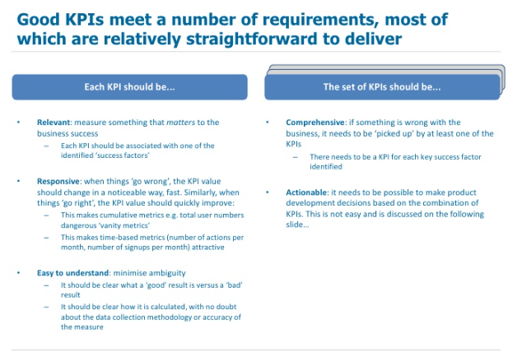

Figure : Email from APA CTO Cannon

Figure : Effective KPI Development

**From**: Cannon, Irene

**To**: Alvarez, Kurt (US – Deloitte)  
**Subject**: RE: APA Mobile App KPIs

**Sent**: Tuesday, October 27, 2015 8:23 AM

Kurt – I received some more clarity around the KPIs. We think it makes more sense to capture the total number of funded initiatives, percentage of our total portfolio of initiatives completed through our new solution, year over year initiative funding increase, and retention rate of users.

A similar commercial platform reached over 175,000 projects complete in FY15 which led to more than $2.5M in funds achieved in a single year. It was amazing to see that over 50% of the time users would engage in another project in the same year. We realize these are lofty goals for our particular case, but we would love to shoot for similar numbers.

Thanks,

Irene

**Irene Cannon**

**Chief Technology Officer**

APA

Phone: (617) 867-9999 | Fax: (310) 211-9999

### Training

A fully implemented solution will only be as successful as the users operating and maintaining the platform. APA will look to continue to stay within budget and timeline constraints while operating their training strategy. Through their partnership with Deloitte they look to obtain a feasible mix of affordability and quality to deliver the proper instructions to their employees.

Figure : Email from APA VP Hodges

**From**: Hodes, Alton

**To**: Cox, Tara (US – Deloitte)  
**Subject**: APA Mobile App KPIs

**Sent**: Monday, October 26, 2015 10:15 AM

Tara,

In the past, APA has done very poorly with providing effective training programs and implementing them on time and on budget. A couple of key items to keep in mind:

* On average, we spend about ~$997per person for 547 employees for training and development. However, our last mobile app cost ~$2,000for each person. We’re hoping that since they’ll be more familiar with mobile technology this time, there will be a smaller learning curve.
* Our employees average about 27 hours of training per year
* Our training deployment hasn’t been engaging for the past 3 years and there’s been a push for techniques that mirror some commercial companies…something to think about.
* Another idea we had was to set up the training earlier on so that we’re more familiar with the software before it hits the markets, ideas on that?

Let me know what your plans are to tackle this.

Best,

Pat

**Alton Hodges**

**VP of Economic Growth & Trade**

APA

Phone: (617) 857-1999 | Fax: (310) 111-9569

|  |
| --- |
| ***Adopted from:*** [*http://www.certifyme.net/osha-blog/elearning-statistics-2013/*](http://www.certifyme.net/osha-blog/elearning-statistics-2013/)  **Training Users**  This will be for the government employees, backend users, or anyone monitoring the system. Building and delivering a brand that is communicated effectively within the organization is extremely important, because every person within the organization needs to be a brand ambassador.  **Examples of Training Methods**  *E-Learning (average cost of $10,000 – $15,600 to create an entire program)*  E-Learning is one of the most important training methods in an organization and can reduce the cost of an organization’s training and development.  *Individual Hands – On Instructor*  Lecture type training will usually be conducted in a classroom-format and though it can be less engaging, it does present a large amount of information to people in a short amount of time. Lectures usually do not have enough interaction, but it’s an inexpensive way to learn basic information like company policy updates.    *Community Group Discussion*  This type of training will most likely take place in a classroom or online forum where users can post/ask questions about the software as well as provide tips/tricks to learning the system. This type of training is usually good because it allows users to bounce ideas off each other and voice their opinions, which could be used to improve the software for the future. Hosting and a domain costs between $190-$200 a year. |

Article 8: Training Users

# 5. Judging Criteria & Presentation Requirements

## Understanding of the Problem

* Recommended solution should address all APA requirements as outlined in the client’s emails and case introduction
* Recommended solution should meet the APA’s ultimate goal of determining the most appropriate deployment and implementation strategy for the microfinancing program

## Recommendation

* Solution should address all key stakeholders
* Solution should be within the realm of the client’s budget and if the solution selected goes over the budget, then justification should be provided
* Solution should address all solution components as outlined in the Case Scenario

## Presentation

* All team members are required to present (equal time distribution is optimal)
* Stay within the time limit (15 minute presentation and 5 minute Q&A session)
* Introduce team members
* Outline presentation topics and discussion areas
* Presentation should flow smoothly
* Utilize supporting materials if necessary
* Should provide additional commentary outside of verbiage on presentation slides
* Exhibit creativity and forward thinking

## Question & Answer Session

* Be prepared to answer questions related to any figures and facts in your presentation, the rationale and methodology your team employed to develop a solution, and the solution as a whole or details surrounding solution implementation
* Don’t fabricate answers to questions you don’t know!